Fill in the required flight details and send this form at least one hour before ETD to ops_helpdesk@lvnl.nl. Mention your phone number in the e-mail message, and wait for instructions and approval.
Call sign: | Type: |  |  | Date: |  | ETO CTR: |  | UTC
ADEP: | ETD: |  | UTC | ADEST: |  | ETA: |  | UTC
Phone operator: |  | Phone PIC: |  |  |  | Name:
SPO declarant No / Yes |  | SPO number: SPL.NL.
Target 1: |  |  |  | Duration: | min | Alt:
Target 2: |  |  |  | Duration: | min | Alt:
Target 3: |  |  |  | Duration: | min | Alt:
Target 4: |  |  |  | Duration: | min | Alt:
Target 5: |  |  |  | Duration: | min | Alt:
Remark:
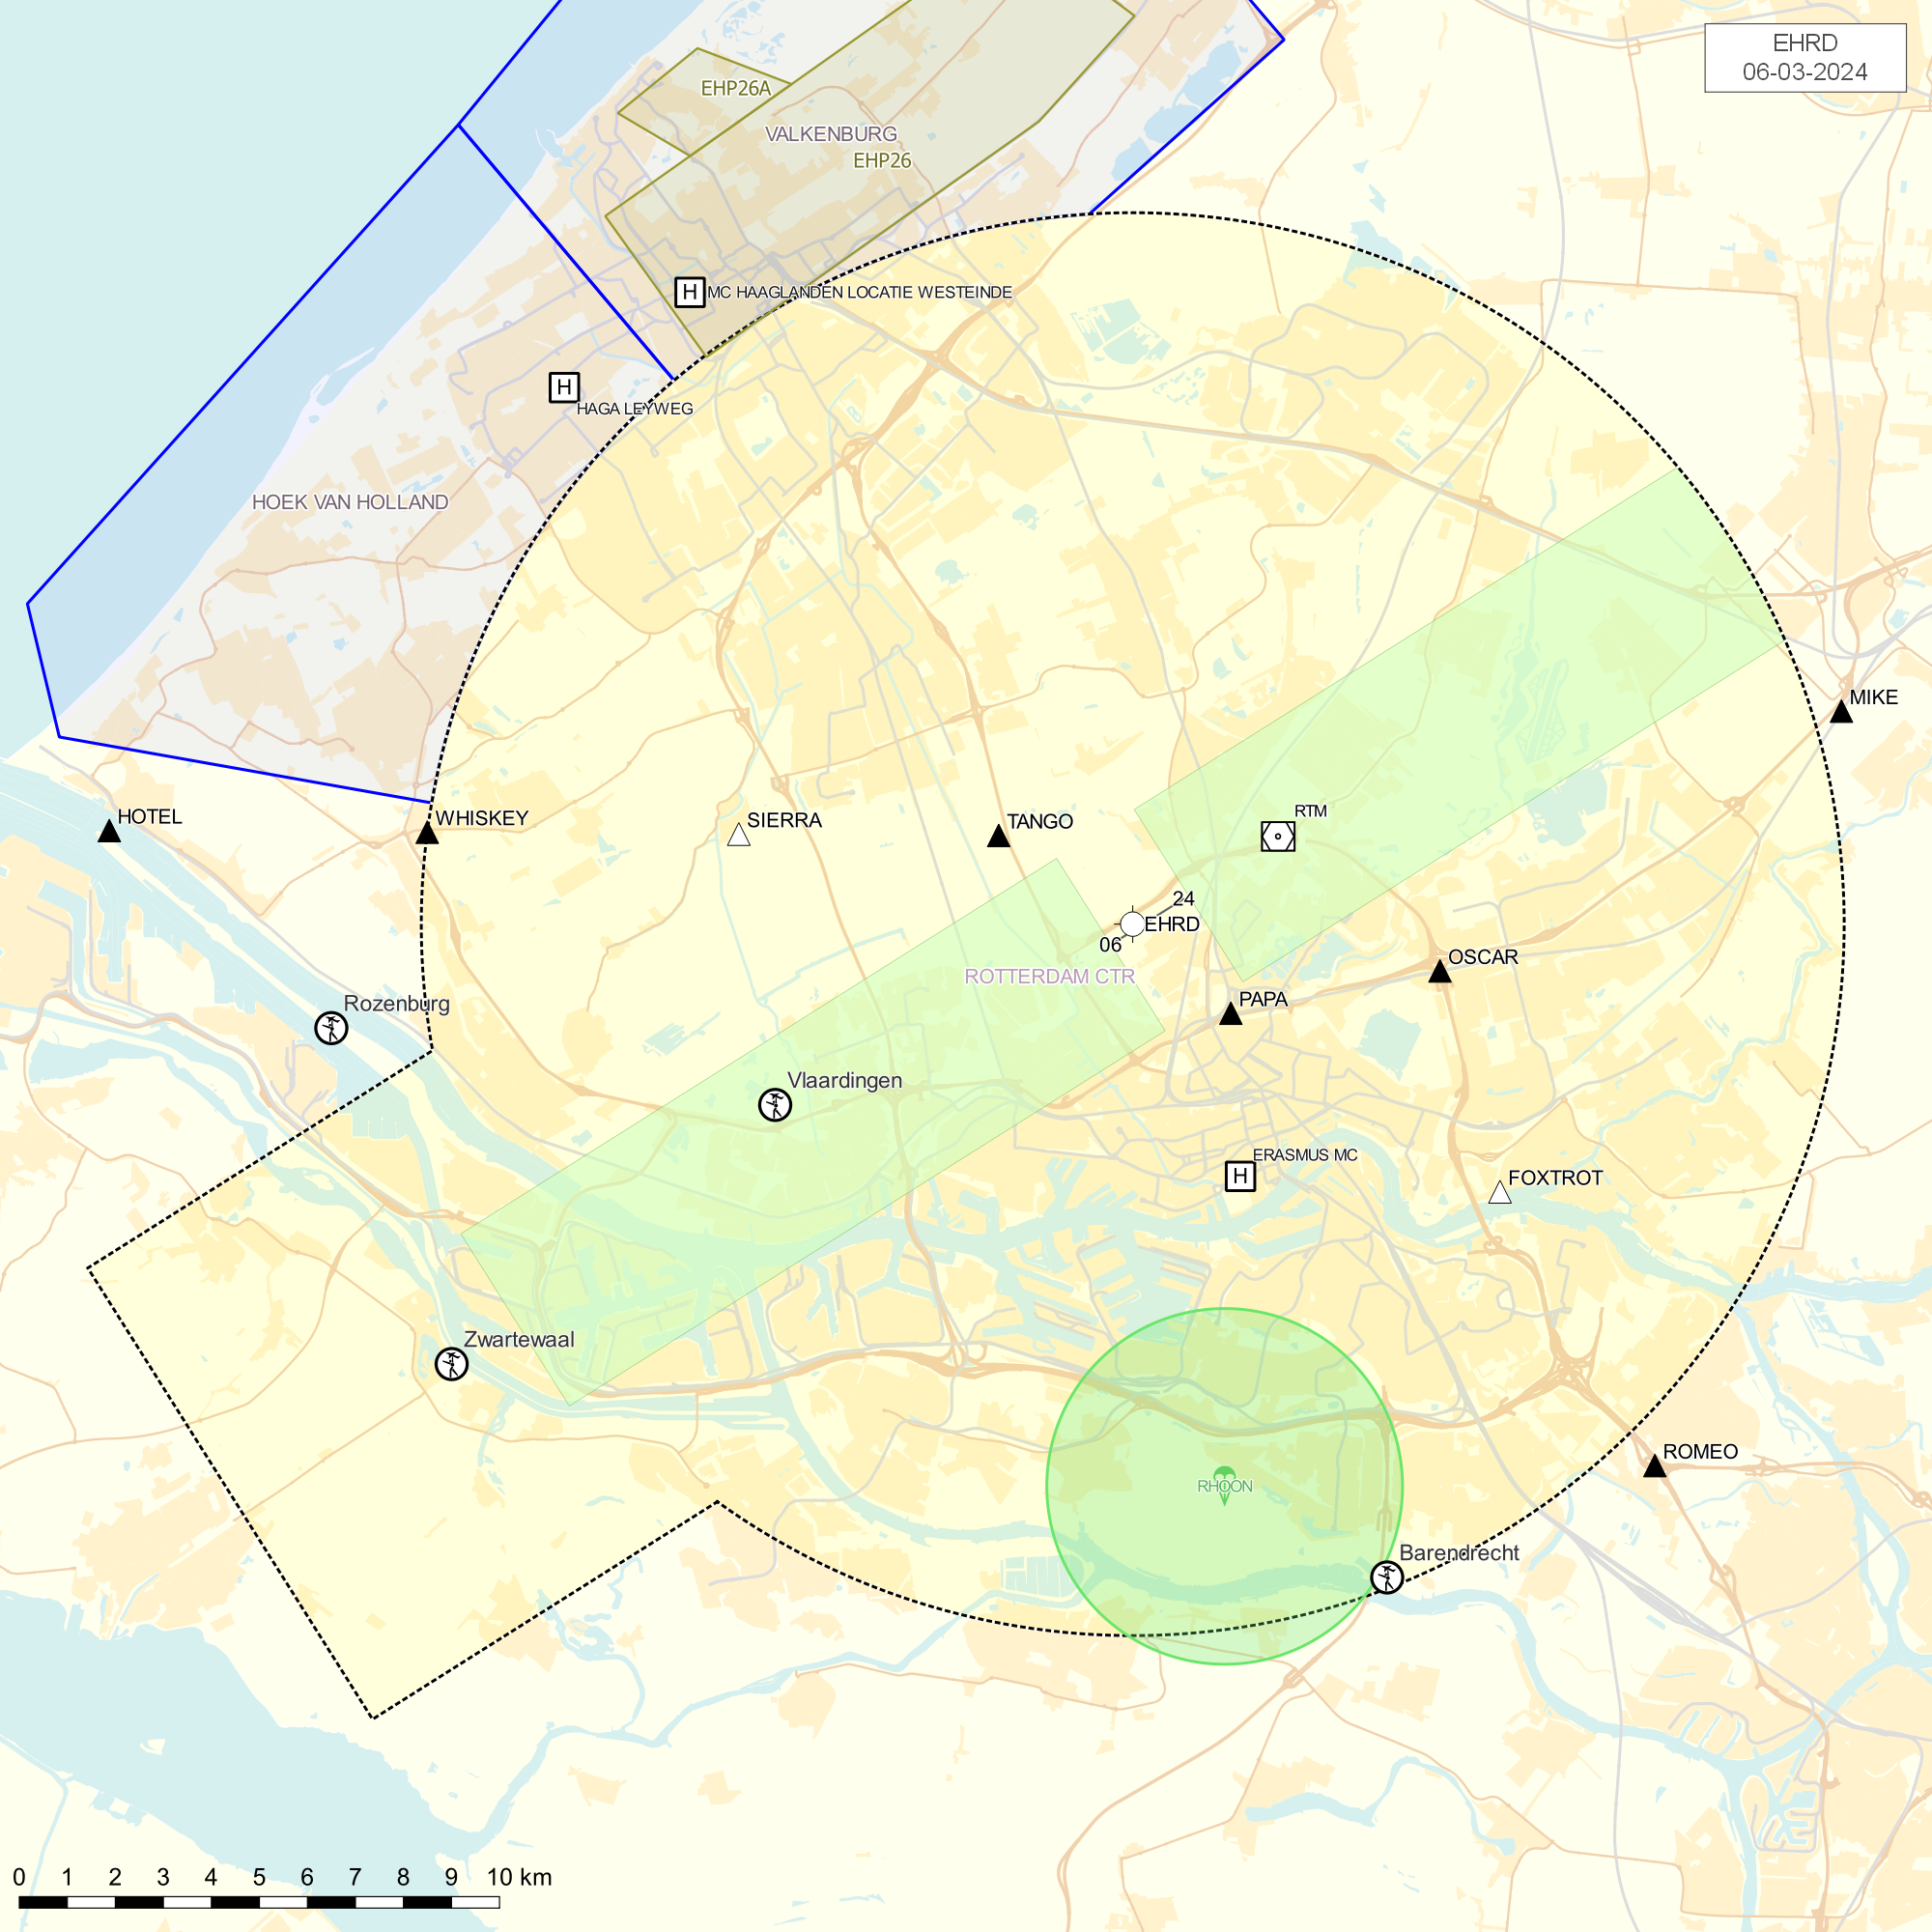
1

2
3
4
5

